 | Abdi İpekçi Caddesi Kaşıkçıoğlu Apt. No:42 D:2 34365 Nişantaşı İstanbul  www.artxist.com  info@artxist.com  T. +90 212 291 77 84 F. +90 212 343 69 35 | PRESS RELEASE

x-ist hosts Bahadır Baruter’s new solo show “Home Sweet Home” between April 30 – May 24, 2014.

BAHADIR BARUTER | HOME SWEET HOME
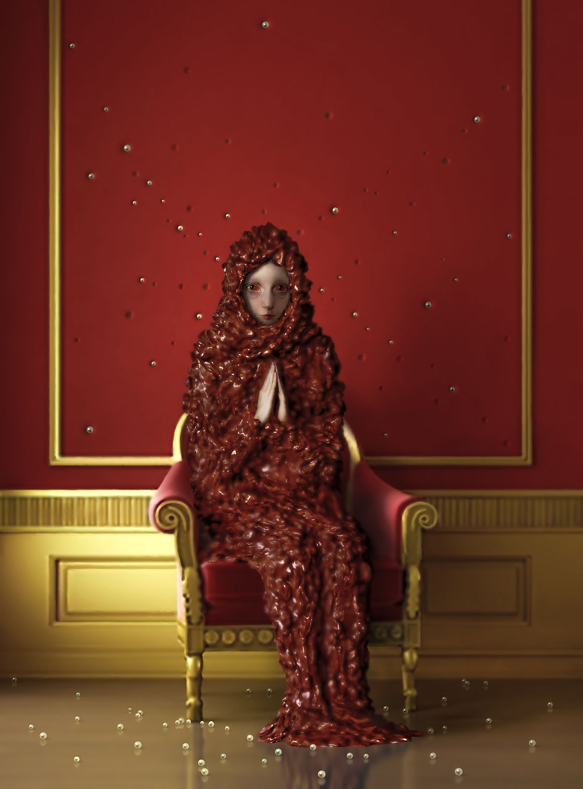
“Baruter, in his paintings takes a deep down, taboo journey into the realm of houses, which he defines as haunted temples. He uncovers the uneasy silence of deep corners of rooms with tightly closed doors, holding secrets which are unknown to even ourselves. Home sweet home...our sweet, capacious and peaceful home, burning itself down; burning us down.

x-ist hosts Bahadır Baruter’s new solo show “Home Sweet Home” between April 30 – May 24, 2014. Questioning societal taboos through intimate portraits, Baruter brings to light hidden realities of the concepts of home and marriage through a fictional narrative.

Bahadır Baruter, "Submission",
165x122 cm, Digital Monoprint with Frame, 2014

As a continuation of his previous show, “Your Family is a Lie, Dear”, Baruter this time delves into the inner worlds of women who are raised with the goals of marriage and raising a family. Peeling off the masks that people put on in order to disguise their true feelings inside a household, Bahadır invites the audience for an introspective look through characters that stare the viewer in the eye. The women in his stories yearn for

the release of their true spirit after realizing the difference between what their dreams offered them and what they are actually experiencing. Now these civilized characters of Baruter desire more than ever a life in touch with their true selves and nature.

We witness an inner inquiry of individuals who feel lonely and insecure at times and captive at others, as a result making semi-voluntary life decisions under the influence of societal structures and rules. “Home Sweet Home” can be seen until May 24, 2014 at x-ist.

For further information please contact to Ece Göymen from x-ist.
ece@artxist.com
M. 555 605 34 65
T. 212 291 77 84

BAHADIR BARUTER | Ankara, 1963

After completing his fine arts education in Mimar Sinan University, Fine Arts Faculty, Baruter started his career as a caricaturist when he was 27 years old and worked for several humor magazines. His solo shows, “Existence Anxiety” (2007) and “Your Family Is a Lie Dear” (2012) took place at x-ist. Baruter also participated in Contemporary Istanbul 12&13 and ArtInternational Istanbul 13 fairs. The artist is the co-founder of the weekly humor magazine Penguen where he has been working as a drawer since 2002.

